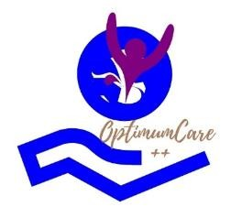

OptmumCare Plus Home Care Package Referral Form

REFERRAL DETAILS
- Referral Date: _________________________________________________
- Referral Managed By: _________________________________________________

PARTICIPANT DETAILS
- Surname: _________________________________________________
- First Name: _________________________________________________
- Date of Birth: _________________________________________________
- Gender: _________________________________________________

GUARDIAN DETAILS (if applicable)
- Surname: _________________________________________________
- First Name: _________________________________________________
- Relationship to Participant: _________________________________________________

CONTACT DETAILS
- Home Phone: _________________________________________________
- Mobile Phone: _________________________________________________
- Email Address: _________________________________________________
- Address:

HOME CARE PACKAGE DETAILS
- Package Level:
  - Level 1 ❒
  - Level 2 ❒
  - Level 3 ❒
  - Level 4 ❒
- Funding Management Type:
  - Self-Managed ❒
  - Provider-Managed ❒
  - Combination ❒

SERVICES REQUIRED
(Please select all that apply)
- ❒ Personal Care
- ❒ Domestic Assistance
- ❒ Social Support
- ❒ Nursing Services
- ❒ Respite Care

- ❒ Other (please specify):

PARTICIPANT NEEDS AND GOALS
(Briefly describe the participant’s support needs and goals)

REFERRER DETAILS
- Name: _________________________________________________
- Position: _________________________________________________
- Organisation: _________________________________________________
- Contact Details: _________________________________________________
- Relationship to Participant: _________________________________________________

ADDITIONAL INFORMATION
(Any other relevant details to assist in providing support)

CONTACT OPTIMUMCARE PLUS
We’re here to help participants maintain independence and thrive in their homes. If you have any questions or need assistance completing this form, please contact us:
📞 08 81646961
📧 info@optmumcareplus.com.au
📍 664 north east road, holden hill

